UWP 7M, Fall 2019
Language and Writing Statement

Learning Outcomes for this Composition:

Writing | Able to effectively write purpose-driven papers that include body paragraph sections and a variety of connective devices, and are sensitive to genre and audience expectations
Use of Sources | Able to integrate outside sources to support opinions, arguments, and counterarguments with citation of sources; demonstrates ability to summarize, paraphrase, and critically analyze sources
Vocabulary Usage in Writing | Consistently able to accurately use general academic vocabulary and to use task-specific content vocabulary to demonstrate an emerging tone and/or style
Grammar Control in Writing | Consistently able to compose multiple paragraphs in a full-length paper with clear ideas and connections, minor grammar errors may appear but do not impede understanding; able to produce an effective variety of sentence types

Topic and Task:
Compose a text that declares 1) your own purposes and goals for your higher education at UC Davis and 2) present how your language and writing practices will be important in your pursuit of these goals. Use the course readings so far to show the complexity of your ideas, to support them, to present counter-evidence, or to illustrate points you are making.

The text must:
- Introduce particular conversations about college students and higher education that we’ve read/talked about in UWP 7M that influence your thinking about the topic of college students and success in college. (part 1)
- Present the non-academic skills students develop in college that help them to be successful and then discuss a specific goal you have and identify and explain the specific non-academic skills that will help you achieve this goal . (part 2)
- Name the most significant language or writing practice that you believe will make a difference to your successful pursuit of your goal and success as a student in general. Describe your key language/writing practice (how it works, when you use it, etc.) and provide illustrative examples of your use of that practice. (part 3)
- Be designed with particular readers (other UWP students) in mind.
- Be between 1000-1200 words.

Assessment:
You will receive feedback from peers and your instructor, and you will receive an “advisory” score/grade from me to give you a sense of how you are meeting the expectations of the assignment. The rubric below describes the expectations of the paper. I also expect you to complete all parts of the composition process (drafting, feedback, and monitoring your process in your writing log,)

(A) | This paper is exceptional. It frames the conversation with the reader clearly by providing thorough context that connects goals/non-academic skills with readings on higher education and the identified language/writing practice. Its organization allows the reader to see you as a knowledgeable guide through the “conversation” of ideas. Summary and paraphrasing are always within an appropriate context and are attributed to the source. Its language is precise and direct and shows attention to word choice and sentence structure.
(B) | This paper is good. It frames the conversation with the reader by providing context that connects goals/non-academic skoses with readings on higher education and the identified language/writing practice. Its organization makes moves to guide the reader through the “conversation” of ideas. Summary and paraphrasing are usually within an appropriate context and are attributed to the source. Its language is clear and shows attention to word choice and sentence structure.
(C) | This paper is passing. It presents the goals/non-academic skoses and the identified language/writing practice, along with information from readings on higher education but may leave the connections unclear/unguided to the reader. The sense of conversation may not be consistent. Summary and paraphrasing are usually attributed to the source but conventions are not consistently applied. Its language is usually clear and shows some attention to word choice and sentence structure.
(D/F) | This paper does not pass. It is incomplete, not following the instructions above, or is very difficult to understand.

The outline to help organize this paper

Language and Writing Statement Graphic Organizer

 | Purpose of college- choose something that you think college students should focus on other than an academic education | Goals/OWN purpose for being in college- How does your own goal connect with what you think college students should learn? | Literacy Practices to achieve the goal- What types of language or writing practices will help you achieve one of your goals?
Key points
Which sources would best help you have a conversation on this topic?
Personal example or other example to help discuss topic:
 | TRANSITION: how do you then connect this to your own goals? | TRANSITION: How do you connect your goals with specific language or writing practices?

My recent paper
Grade: C

Sergio Felix (917188646)
L&W Statement

As readers, we have to know what the goal of why students want to further their education at college is? The one answer to address this question: to prepare them to become successful. But how? Being successful is not easy to earn; most students think that to become a success, they need to get a high GPA and high-paid job by studying and working hard; however, there are also vital facet outside the academic, such as reinvention and non-academic skills that help college students to be successful. Overcoming this two-element of education will prepare students to be ready facing their career, which guides them to become success.

The first illustration that could draw the benefit of attending college is the mental of surviving. In the article “As a Freshman You Can’t Avoid Reinvention,” Navlakha (n.d.) emphasized the hard journey of college students that they had to be more realistic and open-minded to a change, such as changing all of their old behaviors for adapting to their new environment. This is just the first suffering journey that students face, but the lesson from doing this action is beneficial. It opens students’ minds that a change is needed in life to keep survive, which can be likened to deers’ survival strategy. When the thermometer drops drastically, deers do a couple of things differently: eat more and move less to survive. In this case, deers realize that they have to change their behavior in order to keep survive
(source: https://www.buckscore.com/strategies-deer-use-to-survive-the-winter-months-and-what-you-can-do-to-help-them/ ). By this example, it implies that a change is good to be implemented as long as it could give us the advantage, which in the students’ case, students will be able to keep remain at college for the long term without having trouble. Thus, if students could survive at college, they will also be able to survive in their career because they have already been trained well.

Furthermore, by attending college, students will learn some new experiences, which support students’ success, such as a sense of belonging that barely can be found in other places. Chambliss & Takacs (n.d.) argued that belonging was a critical factor for college students, which provided them so many advantages, one of the examples made students work harder in various fields of student life, such as sports, extracurriculars, and academics. Chambliss & Takacs (n.d.) also found that belonging could also give more chances of success to college students because the students had the incentive to stay with other members, which made students push beyond their limits. For example, my cousin James, who used to have the motivation to stay with other members at Colombia University, becomes a sales director in Samsung Company in Indonesia because he never wants to fall behind from another employer and never satisfied with her work results. Therefore, the advantages of the college, like belonging, can be felt by students in their careers.

Unfortunately, these two advantages of being college students cannot be that useful if students do not have the non-academic skills to support the benefits. Although there are so many non-academic skills that can be learned at college, such as characters, soft skills, and growth mindset and useful for students’ success, one of the most crucial non-academic skills that students should learn is grit. In his article “Non-academics skills are key to success,” Kamenetz, the author, put grit as one of the keys to success. Oppong (2018) once said, “Grit is a combination of passion and perseverance, a belief that failure can be overcome. It is a willingness to conquer challenges, instead of avoid them”. When students have grit, their chances to become successful are higher because grit is an ability to persist on something we feel passionate and refuse to give up no matter how hard it is, which they will never stop until they achieve their success (Feldman, 2017). Otherwise, if people do not have grit, they will be giving up quickly every time significant obstacles occur, which prevents them from becoming a success.

Why is grit essential non-academic skill? To support my first argument, which the idea is from the article “As a Freshman You Can’t Avoid Reinvention,” a grit is required because a change is hard to establish. If students give up easily, they will never be able to make a change to adapt to our environment. Although it is hard to have and maintain a change, students have to do it for their goodness sake. Furthermore, to connect to my second opinion, which the idea is from the article “Belonging,” a grit is also needed to remain and to stay in the group no matter how difficult it is (Chambliss & Takacs, n.d.). Students know that belong is not easy; therefore, they have to put more effort into it, which motivates them to work harder in a particular field of study, such as sports, extracurriculars, and academics (Chambliss & Takacs, n.d.). If they do not have the grit, they will never be able to belong in the group and fall into despair (Chambliss & Takacs, n.d.).

Moreover, becoming a CEO in a huge company has been my specific goal since I was ten years old when I see my cousin was successful in making tons of money in Indonesia. I realize that to become a CEO is not an easy task, since all the decision-makers are on the CEO, and it requires everyone who also wants to be a CEO to have significant language and speaking practices. Therefore, while I have the opportunities to further my education at UC Davis, I will start practicing in both areas of practice. In language practices, I will enrich my vocab by reading a literature book and talk to native speakers frequently to train my fluency in English. This language practice is so essential because a CEO has to be able to speak out clearly and fluently when making a company strategy with the employees or making cooperation with the clients. In writing practices, I will learn to have feedback and be open-minded to other people’s arguments because sometimes their opinion is way better than mine. Therefore, every time the CEO wants to make a decision, he must hold a meeting first with his employee or stockholder, so the outcome decision is favorable to everyone and the company. I can start learning this practice by receiving feedback from my peer review in the UWP class. If I have already done all of these practices, and it combined with the spirit of grit, I will be ready to be a decent CEO in the future. In general, if students focus on their goal and eager to keep practicing all the time with the spirit of grit people, they will end up in their success.

In conclusion, students can reach their goal and become success if they have done both writing and speaking practice and also have mastered in both academics and non-academic skills.

The feedback from my professor

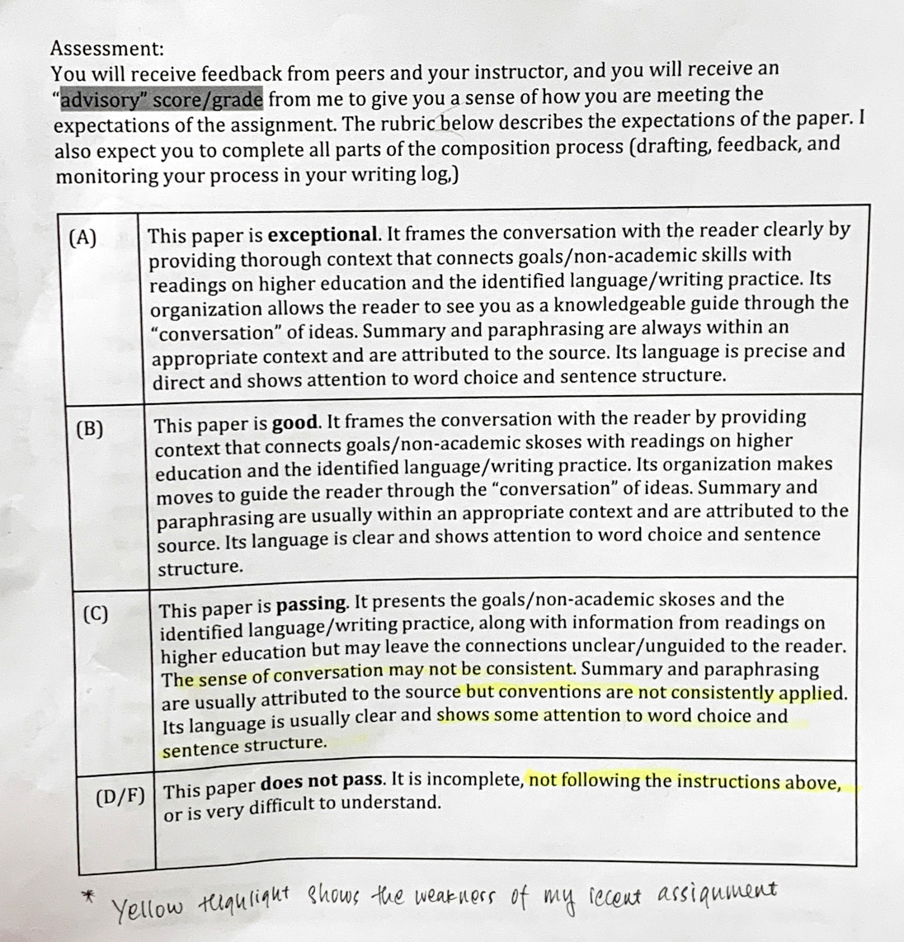

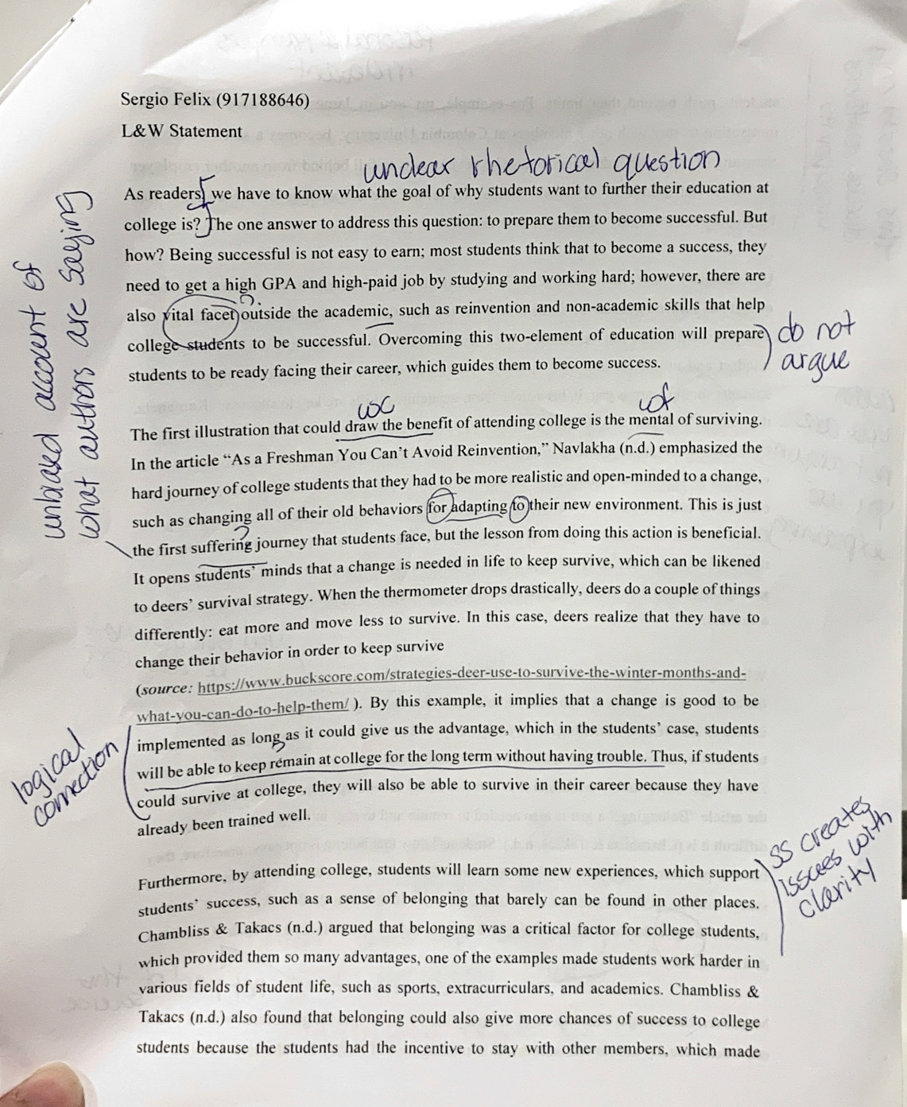

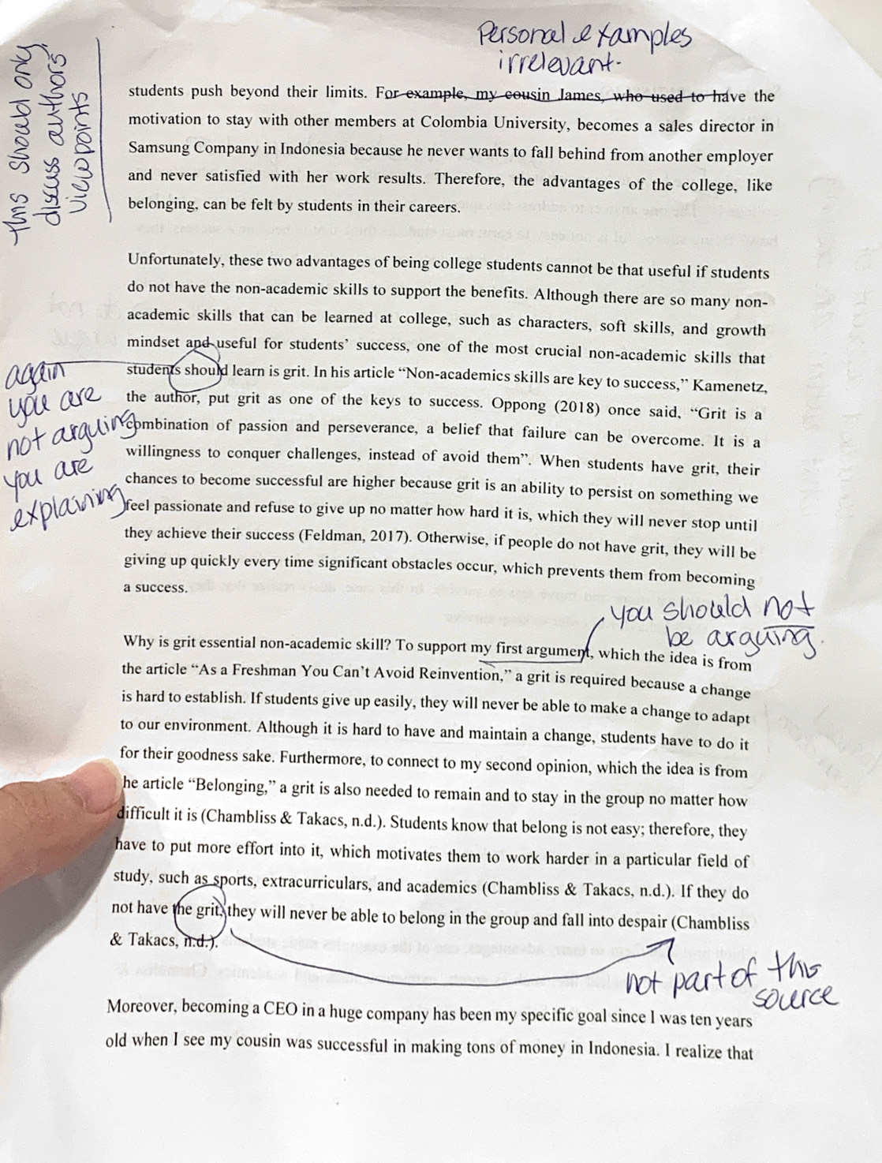
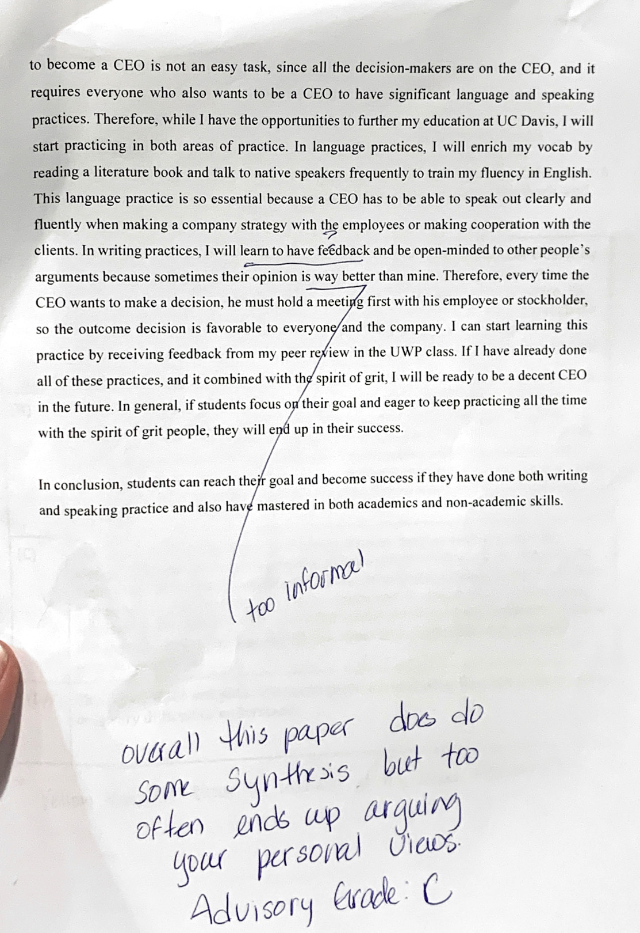
Source that I use for doing this assignment:

a. “Non-academics skills are key to success” by Anya Kamenetz
https://www.npr.org/sections/ed/2015/05/28/404684712/non-academic-skills-are-key-to-success-but-what-should-we-call-them
b. “As a Freshman, You Can’t Avoid Reinvention” by Meera Navlakha
https://www.nytimes.com/2018/01/03/opinion/reinvention-college-freshman-change.html

c. “Belonging” by Chambliss and Takacs

Belonging
I’m kind of shy . . . But I’m in rugby, and that’s good for meeting people. And let’s see, what else? I’m in jazz and that’s good . . . And then there’s sailing, but we’re not very active so it’s hard to meet people. I’m a member of the College Democrats, and I meet people through that. I go to [gospel singing events] and I meet people that way. And I’m in the Philosophy Club, I’m the treasurer of that . . . (Joe, sophomore)
By the middle of sophomore year, almost all students at the college belong. They have publicly committed themselves by declaring a major, by choosing or refusing roommates, by selecting a faculty advisor, by sticking with or quit- ting a sports team, and by joining, leading, or leaving a number of extracurricular activities. Some students are members of the campus “alternative” crowd: living in a co-op dorm, eating on the vegetarian meal plan, maybe studying photography or art.1 Others are sorority officers, maybe planning to study abroad in Italy while majoring in art history. Some like Joe, quoted above, are deeply immersed in extracurriculars. Some spend six hours a day in the gym, while others are engrossed in experiments in a chemistry or neuropsychology lab. Almost everyone identifiably belongs to particular informal and formal groups on campus—a gang of friends, a yearbook staff , an intramural softball team, a fraternity. They have made their choices and found their places in a manageable combination of academic study, extracurricular activities, and hanging out with friends.
Students’ strenuous efforts to “ fit in” and and a place are well spent. Over and over, researchers have found that integration is crucial to students’ remaining in college,2 and most students’ main concern at college is to find a
Brought to you by | University of California - Davis Authenticated Download Date | 1/29/19 10:43 PM
BELONGING 79
stable and enjoyable peer group.3 Faculty may grouse (such faculty complaints go back for centuries4), but students have always put social life ahead of academics. Integration doesn’t just prevent students from leaving college; it is also important, in a positive sense, for their learning, success, and happiness in college.5 In the correct cocktail of ingredients, integration—“belonging”— can generate major positive outcomes.
Belonging, we think, is central to how colleges operate as effective educational institutions. Belonging isn’t abstract; real things that happen in daily life create the feeling—the reality—of belonging to groups and to the com- munity they make up. When like-minded people gather around shared topics or interests, they can become energized around those topics. Once a person belongs to an energized group, she has an incentive to remain and to stay on good terms with other members. e shared topic that brought them together (music, a sport, partying, an academic topic) becomes valued, as much as a symbol of that collective energy as for its own sake. Being-together, we suggest, motivates students to throw themselves into work, or into sports, extracurriculars, partying, or even religious study. Students work hard in order to demonstrate their membership, maintain their relationships, and live out their identity. And in turn, when such groups are successful in engaging their members, they can become more influential, even coming to dominate the campus culture, while students who don’t belong can languish or, at worst, fall into despair. In this chapter we explore how such belonging.

